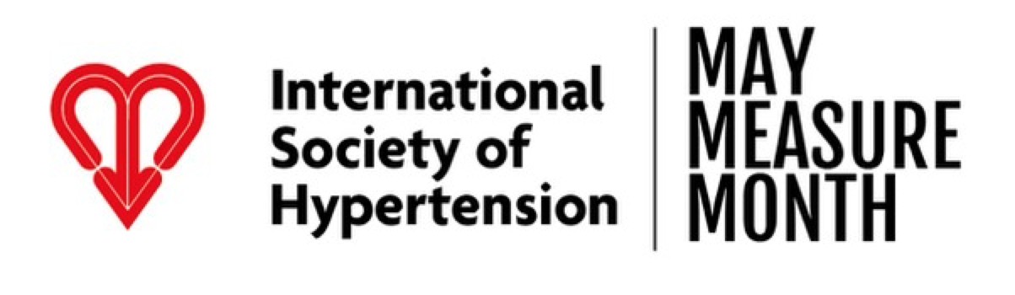

PRESS RELEASE

[insert name of participant/country] proud to support 2021 May Measurement Month

People in [insert country] encouraged to get screened for high blood pressure

[insert country] [insert date]: As the International Society of Hypertension (ISH) launches the worldwide May Measurement Month (MMM) for the fourth year since 2017, [insert participant] are excited to announce their involvement in this landmark global blood pressure screening initiative. They call upon the general public in [insert country] to take advantage of this important opportunity to get their blood pressure tested.

Raised blood pressure (BP), or hypertension, is the single biggest risk factor responsible for mortality worldwide¹. It is estimated that in [insert country] alone, [insert number] have raised blood pressure, putting them at risk of some serious long-term complications if left untreated. The majority of people with raised hypertension are either completely unaware of actually having it, and are untreated, or are on treatment which is not effectively controlling their condition. As the condition has no noticeable symptoms, blood pressure measurement is the only accurate way of identifying hypertension, and therefore of critical importance. The good news is that BP is easy and inexpensive to measure, and several effective drug treatments are available to control hypertension.
This was the impetus behind MMM – a global campaign aimed at raising awareness of high blood pressure, its potential long-term implications and the importance of controlling it. It is the world’s largest free public blood pressure screening campaign and from May until the end of the year, volunteers around the world will measure the blood pressure of people in their cities, towns and villages. [Insert participant / country] are proud to be running May Measurement Month in their country and aim to get as many of the local population tested. All participants leave knowing their blood pressure level and anyone who is registered as hypertensive is given advice about what to do next.
In 2017, the first year of May Measurement Month, over 1.2 million people were screened in 80 countries across the world. This is the [first / second / third / fourth] time that [insert country] has taken part in the campaign and are looking forward to [testing as many people as possible / testing more people than in their previous year (insert figures)].
In its first year, May Measurement Month globally identified over 100,000 people with hypertension who were not actually on treatment and over 150,000 people on anti-hypertensive treatment but who were not effectively controlled. The campaign provided a significant cross-sectional survey of blood pressure in adults across the world.
MMM’s Chief Investigator, Professor Neil Poulter, said: ‘Even with increased threats to public health this last year, raised blood pressure remains the biggest single contributing risk factor for global death and the worldwide burden of disease. We want May Measurement Month to increase public understanding and help save lives that need not be lost.’

Thankfully, MMM will be back in May 2021. It remains to be the largest global blood pressure research project with 87 countries, aiming to test over 1 million people between May and November 2021.

[Insert participant / country] is asking people in [insert country] to find out how where and how they can get tested by going on to maymeasure.org Here, they will find an interactive map which shows where their local screening centre is and also how they can test themselves from home.

Please visit maymeasure.org for more information about the campaign and how to get tested

Notes to Editors

About hypertension
Raised blood pressure (BP) remains the biggest single contributor to global death and global burden of disease². It is estimated that in 2019 about 19% of all deaths (10.8 million) were due to raised BP, having risen from 9.4 million deaths in 2014.³ Hypertension causes over 50% of cases of heart disease, stroke and heart failure.⁴ and it is estimated that about 10% of global health care spending arises from raised BP and its complications⁵. Moreover, hypertension-mediated organ damage increases risk of severe infections from COVID-19, including risk of death.⁶

About MMM
May Measurement Month (MMM), the global campaign run by the ISH to raise awareness of the need for people to get their blood pressure checked, will be back in May 2021. After three successful years, MMM was naturally forced to pause in 2020, but is returning in the spring with increased energy, asking people to ‘roll their sleeves up’ and take action. May Measurement Month has been extended this year to run between 1 May – 30 Nov and builds on the World Hypertension League’s established World Hypertension Day (held on 17 May each year) with volunteer health professionals at local screening sites, in more than 80 countries.

About International Society of Hypertension
Established in 1966, the International Society of Hypertension (ISH) is committed to promoting and encouraging the advancement of scientific research and knowledge and its application to the prevention and management of heart disease and stroke in hypertension and related cardiovascular diseases around the world. The Society is a registered charity.
In 2017, the then President of the ISH Professor Neil Poulter launched a health awareness campaign – ‘May Measurement Month’ (MMM).

MMM aims to improve awareness of blood pressure at the individual and population level.

MMM has included over 4.2 million screenings across the first three annual campaigns and has grown each year in terms of number of countries involved and total participants. The detection of over 900,000 adults with untreated or inadequately treated hypertension during these three years, attests to the benefits of such opportunistic screening.

For more information about [insert country]’s participation in May Measurement Month or to speak to the programme leads, [insert country programme leads] please email [insert email address].

Thank you to MMM sponsors; OMRON (www.omron-healthcare.co.uk) and SERVIER (www.servier.com)

References
- World Health Organisation (WHO) ,Global Health Risks Report 2009 https://www.who.int/healthinfo/global_burden_disease/GlobalHealthRisks_report_full.pdf
- GBD 2017 Risk Factor Collaborators. Global, regional, and national comparative risk assessment of 84 behavioural, environmental and occupational, and metabolic risks or clusters of risks for 195 countries and territories, 1990-2017: a systematic analysis for the Global Burden of Disease Study 2017. Lancet. 2018; 392:1923.
- GBD 2019 Risk Factors Collaborators. Global burden of 87 risk factors in 204 countries and territories, 1990-2019: a systematic analysis for the Global Burden of Disease Study 2019. Lancet. 2020;396(10258):1223-49.
- Forouzanfar MH, Liu P, Roth GA, Ng M, Biryukov S, Marczak L, et al. Global Burden of Hypertension and Systolic Blood Pressure of at Least 110 to 115 mm Hg, 1990-2015. JAMA. 2017;317(2):165-82.
- Gaziano TA, Bitton A, Anand S, Weinstein MC. The global cost of nonoptimal blood pressure. J Hypertens. 2009;27(7):1472-7.
- Yang J, Zheng Y, Gou X, Pu K, Chen Z, Guo Q, Ji R, Wang H, Wang Y, Zhou Y. Prevalence of comorbidities and its effect in patients with CARS-CoV-2: a systematic review and meta-analysis. International Journal of Infectious Diseases. 2020. 94:91-95.

